**MACM 316 – Computing Assignment 3 Report**

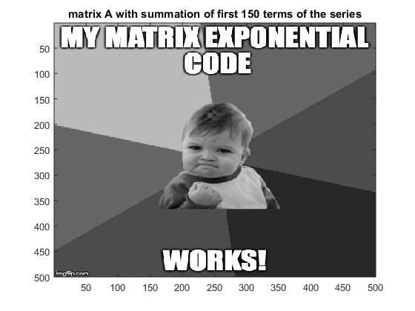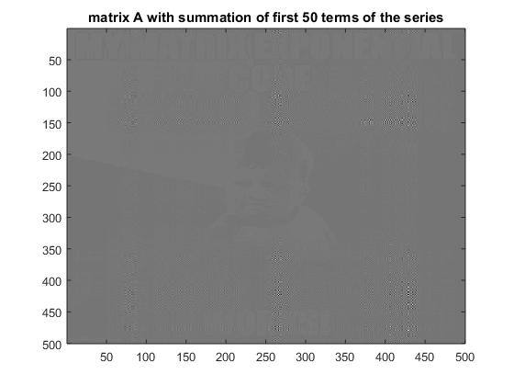  
As shown from the top left figure, when an approximation to the exponential of matrix A using only the first 50 terms of the Taylor series expansion, it has a very poor accuracy output. However, when we take the first 150 terms into account, the output clearly is a more accurate approximation to the exponential of the matrix. Hence, approximating with more terms of the Taylor series expansion produces a more accurate image output but the algorithm will take longer to execute at the same time.

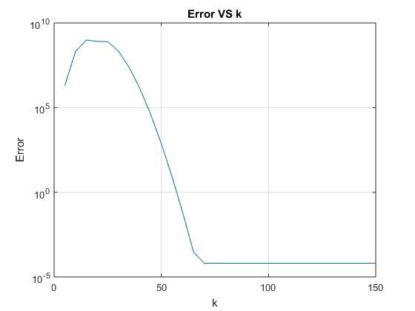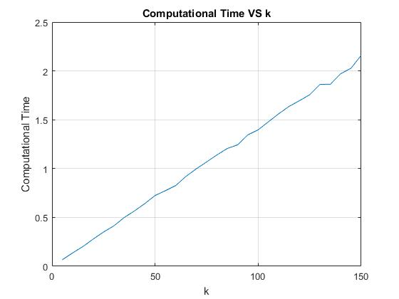

As shown on the Computational Time VS k figure plotted using the tic and toc commands, the computational time increases almost linearly as k increases resulting an output that almost resembles a linear line. In terms out FLOPS, I first initialized expAk as an empty 500*500 matrix and variable matrix as a 500*500 identity matrix. Afterwards I sum expAk and variable matrix iteratively with a for loop and this requires 1 operation per iteration. And then for the matrix multiplication part, it takes n*n*(2n-1) operations by setting variable matrix to matrix A times by variable matrix divided by the iteration. Since n=500, the FLOPS = 500*500*(2*500-1) =   
250000*(999)*k which grows linearly. Thus, the behaviour of the figure showing agrees with what I expected from the calculation of FLOPS.

As shown from the Error VS k figure, the error of approximation is extremely big when k is roughly within 0 to 40. Once k > 40, the error gradually decreases all the way down to nearly 10^-4 when k reaches 70. This phenomenon is reasonable because the greater the value of k is, the more terms of Taylor series expansion sums together, which results in a more accurate approximation of the exponential of matrix A. The algorithm is relatively accurate when k is greater than 70. In terms of robustness, I would not consider the algorithm is robust in comparison with the machine epsilon. Because the error lowers down to around 10^-4 when it is stabilized, but it is still not robust enough in comparison with 10^-16 the machine epsilon.